ELB (CLB) Load Balancer with HTTP and HTTPS
- get a index.html
- create a S3 bucket and upload index.html
- create a role s3 admin with s3 full access
- create SG with port 22,80,443,53
- create a instance in ap-south-1a with IAM role, bootstrap script
- create a instance in ap-south-1b with IAM role, bootstrap script
- create CLB & attached both instance
- for HTTPS please create the certificate from ACM and add the domain in ACM
- then create the load balancer with https port

- get a index.html
- create a S3 bucket and upload index.html
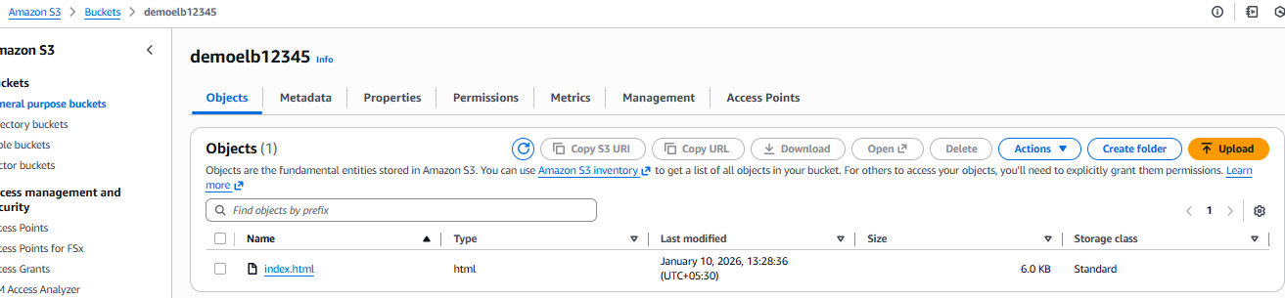
- role has been created with s3 full access on EC2 instance
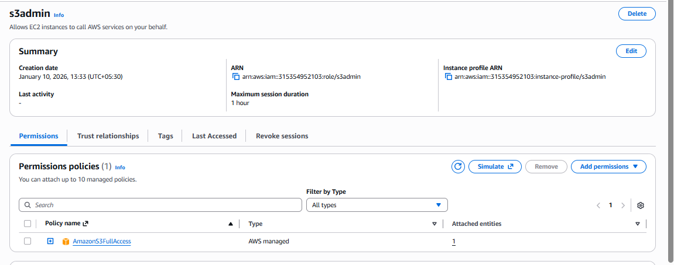

- security group has been created with below mention port
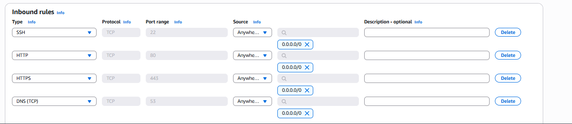

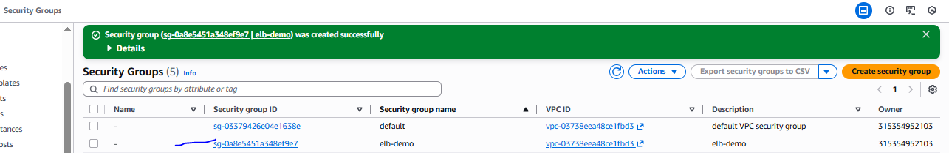

- 1st Instance has been created with custom SG which we have created, IAM role bootstrap script created
#!/bin/bash
yum install -y httpd
aws s3 cp s3://bucketname/index.html /var/www/html/
service httpd start
chkconfig httpd on
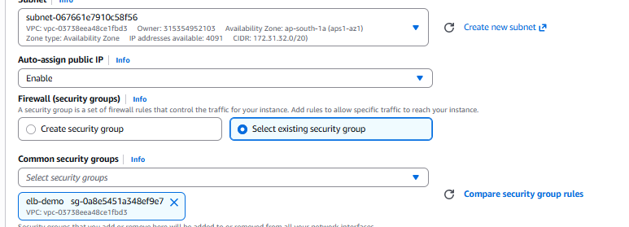

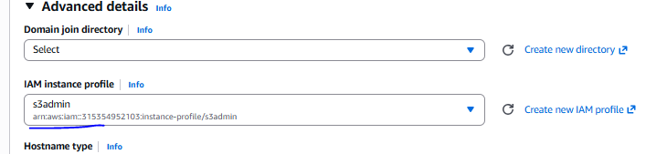
- Similaraly create a 2nd instance in other AZ with similar configuration (boostrap,IAM role and security group)

Note: I choose Singapore region due to the encounter connection issue in Mumbai region.

Instance has been created and running fine as expected
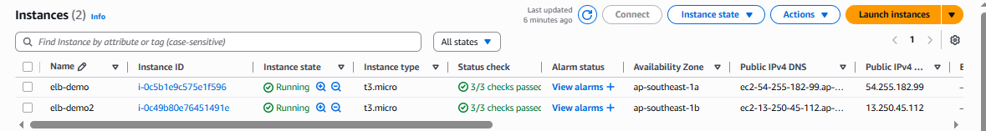

- Then create one CLB and attached the both instance to CLB
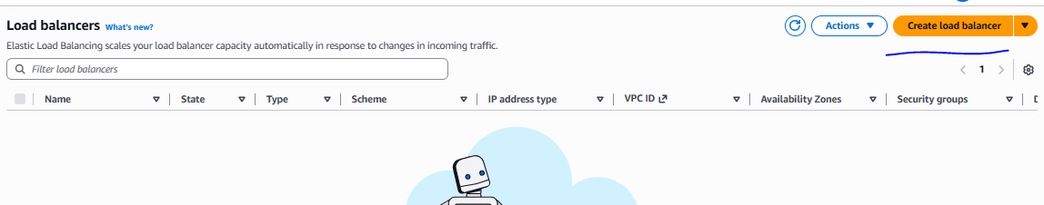
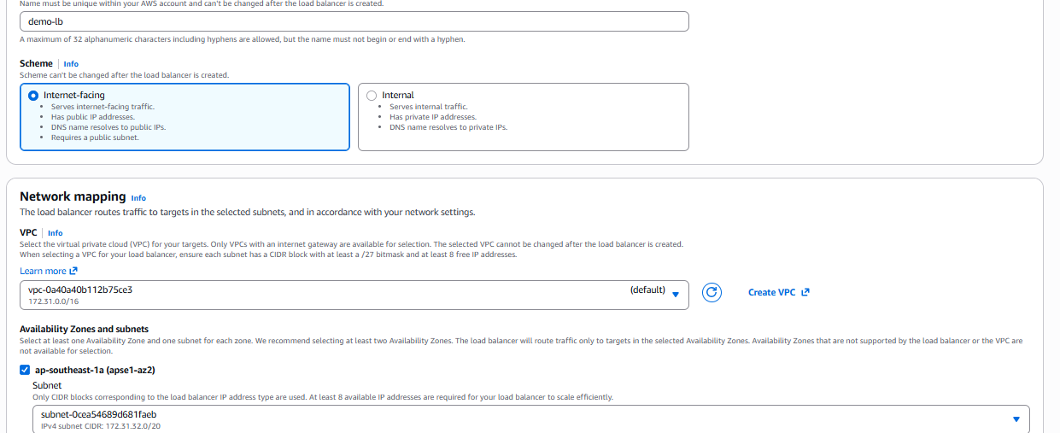
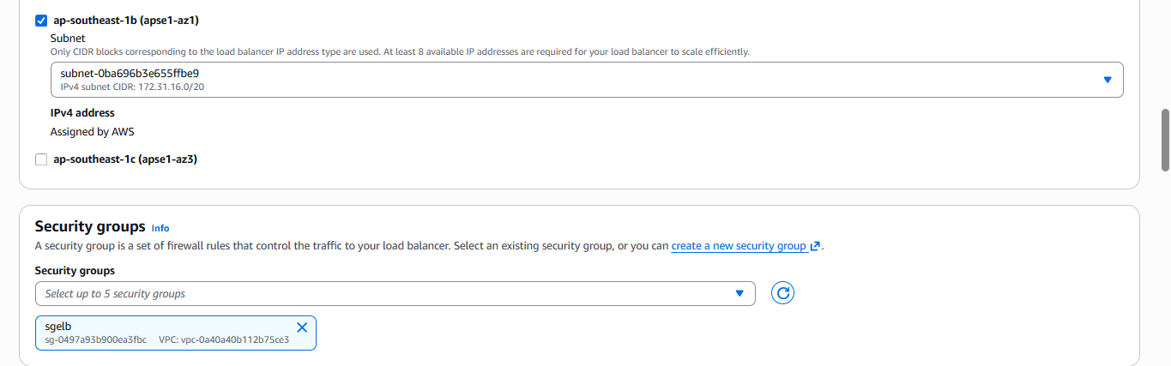
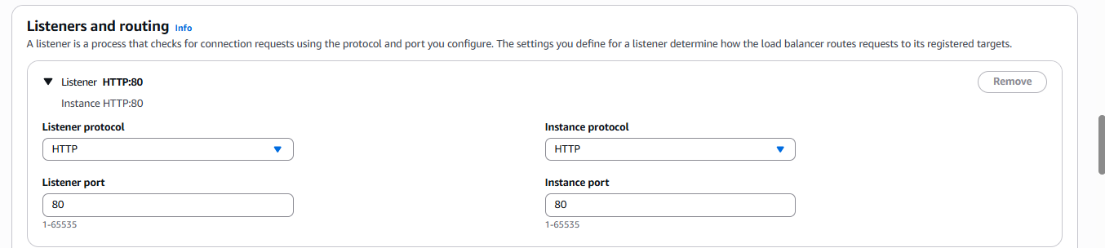
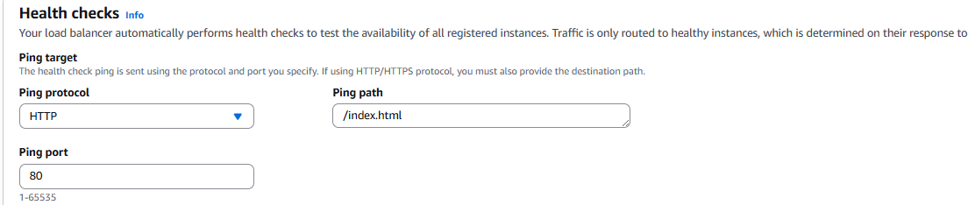
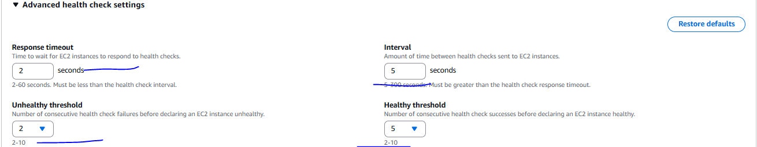
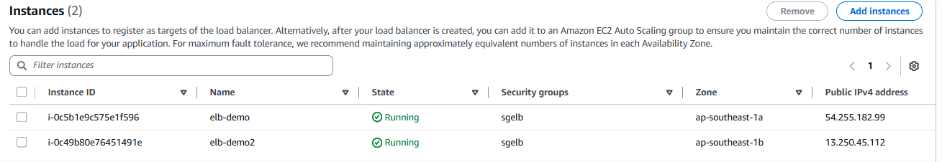

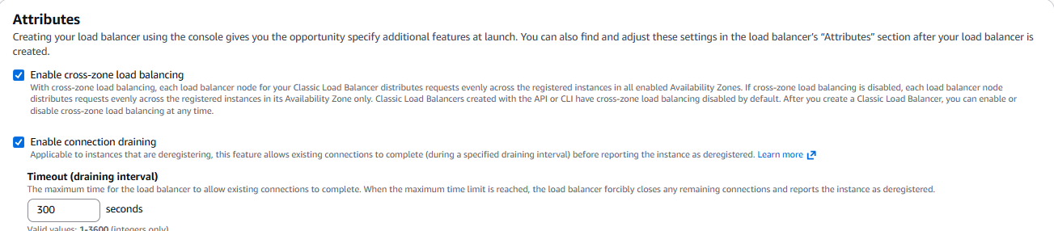
Then create
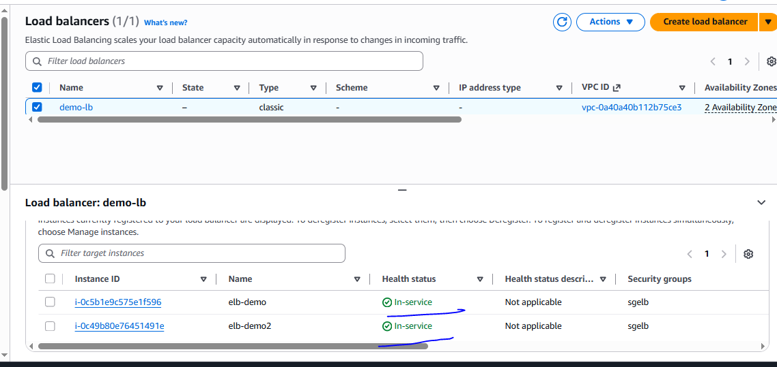

CLB verified with Domain name
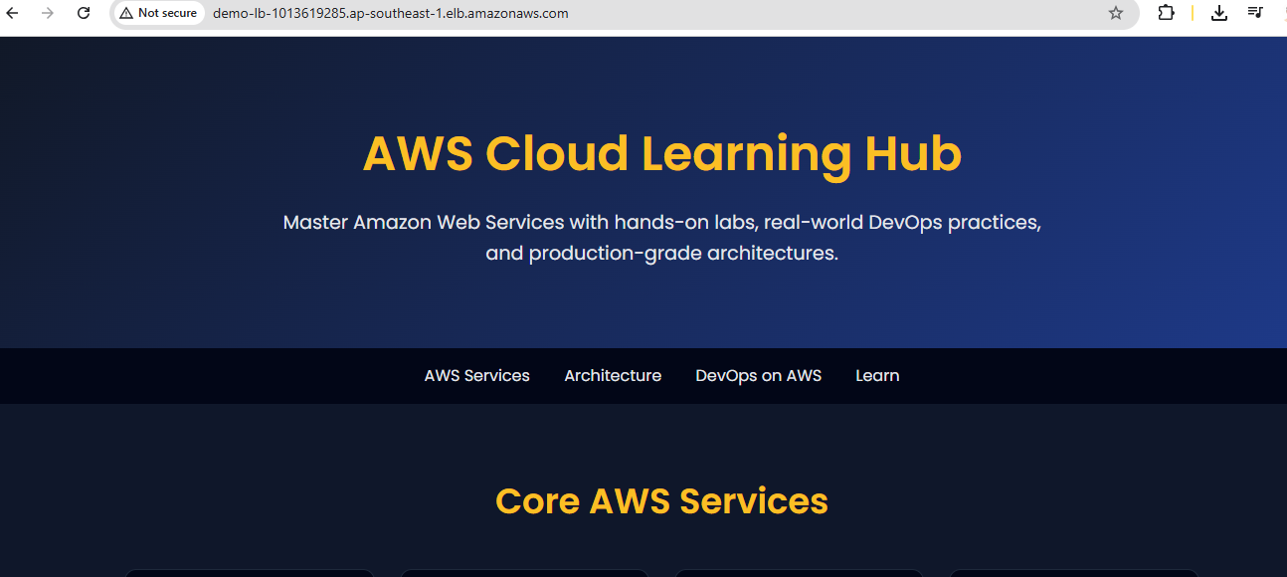

- Load balancer route to particular domain using route53
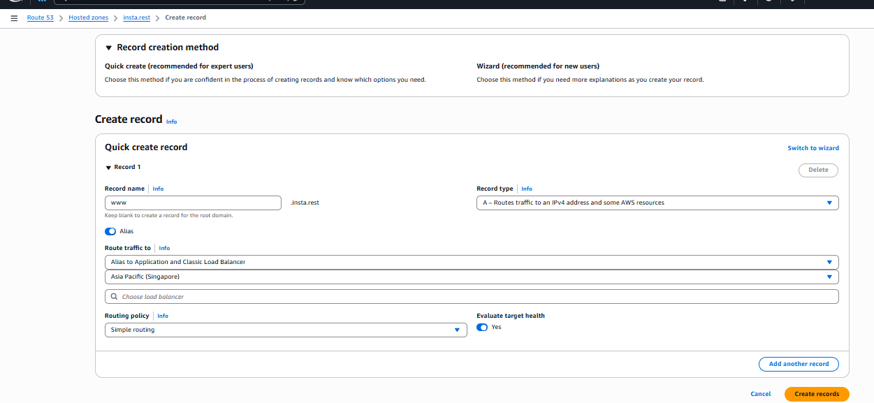
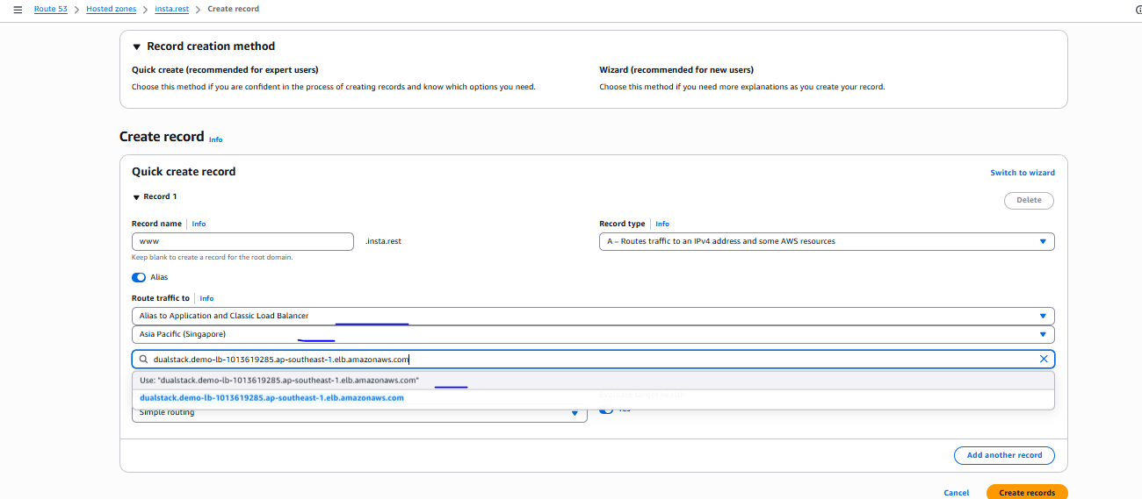
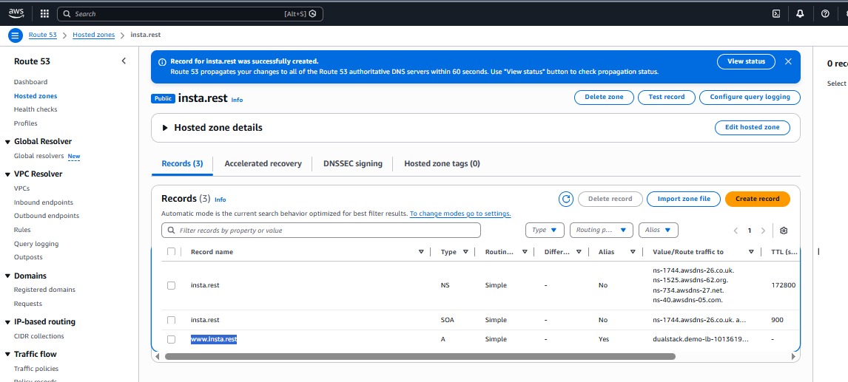
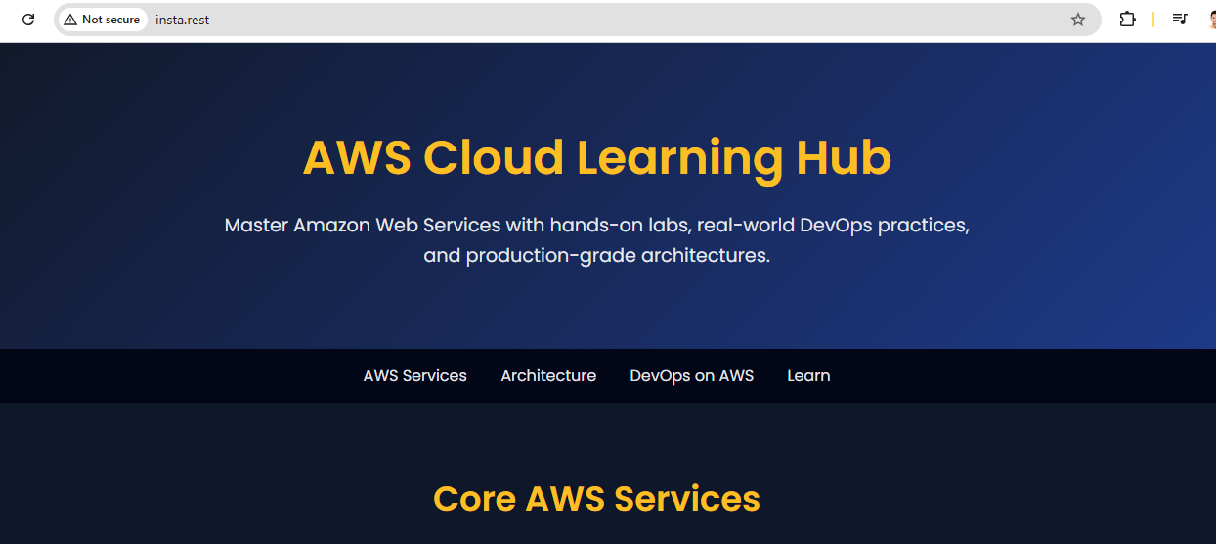

# Website need to secure so for this we need to generate the certificate with ACM server, once certificated generated need to attached on website which we have hosted in route 53
- Generate the certificate
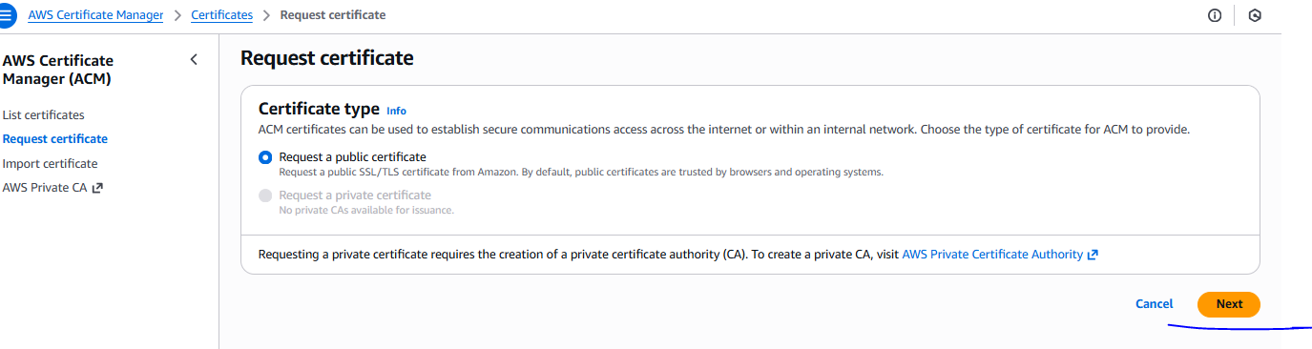
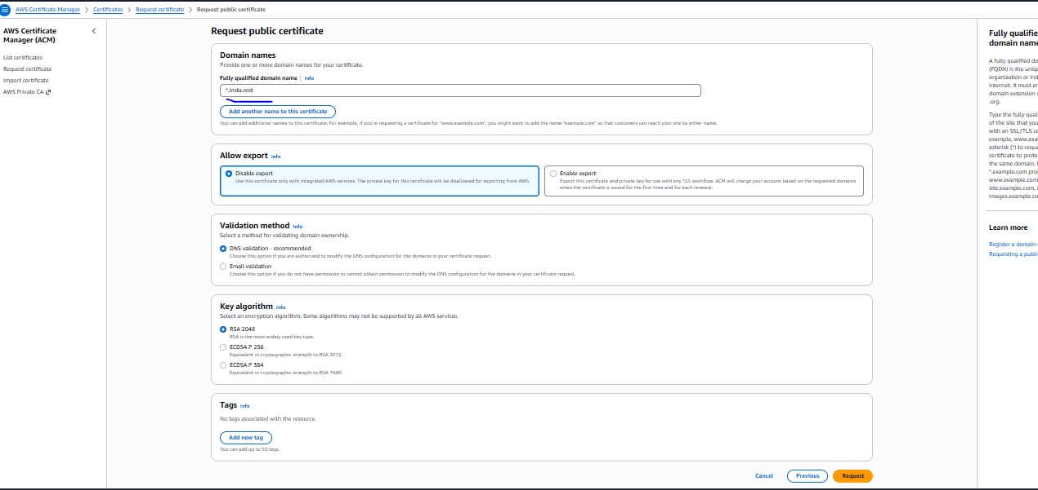
Certificate issued but still is in pending validation
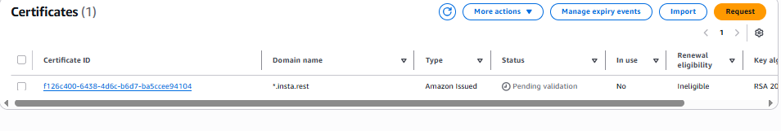

For validation need to perform below step
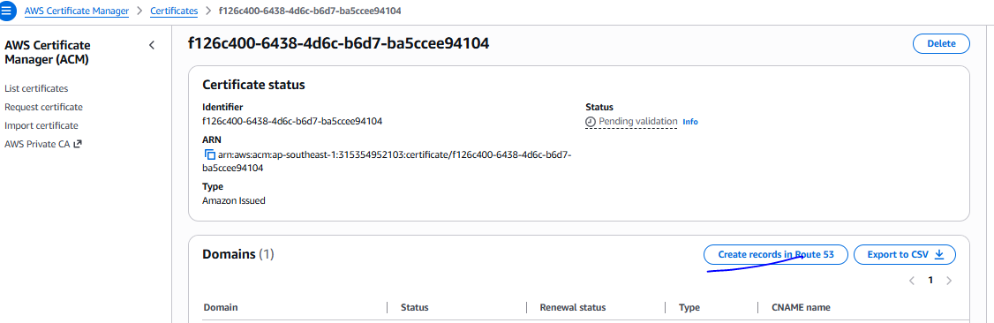
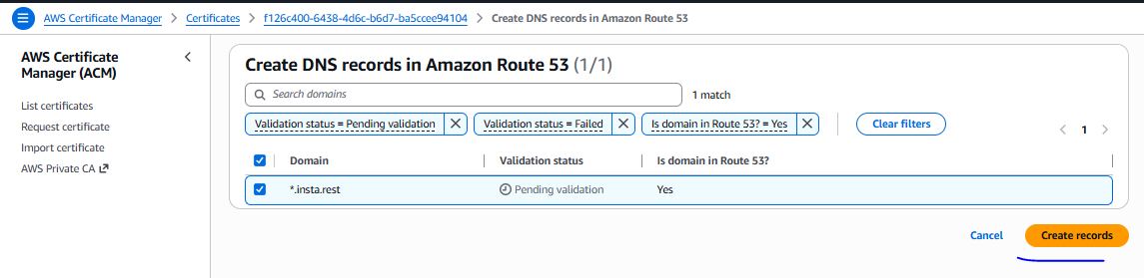
After validation certificate issued
certificate present in Singapore region

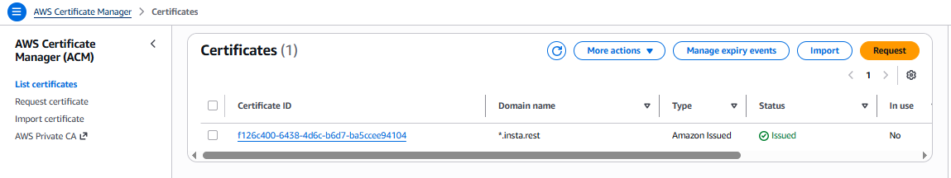

Once certificate assign need to create CLB with same configuration need to additional configuration as mention below
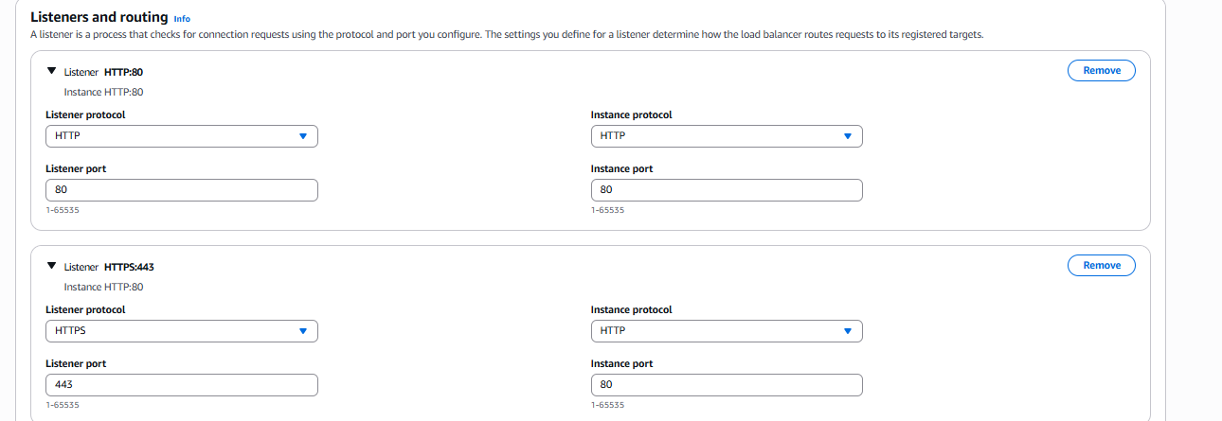
For HTTPS we have a two lister
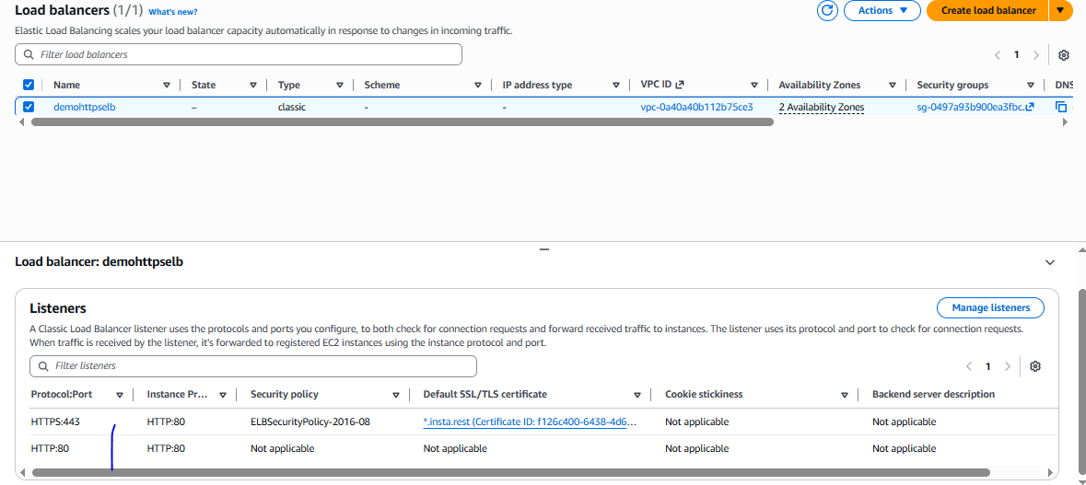
https page also loaded
